Fabric Git integration
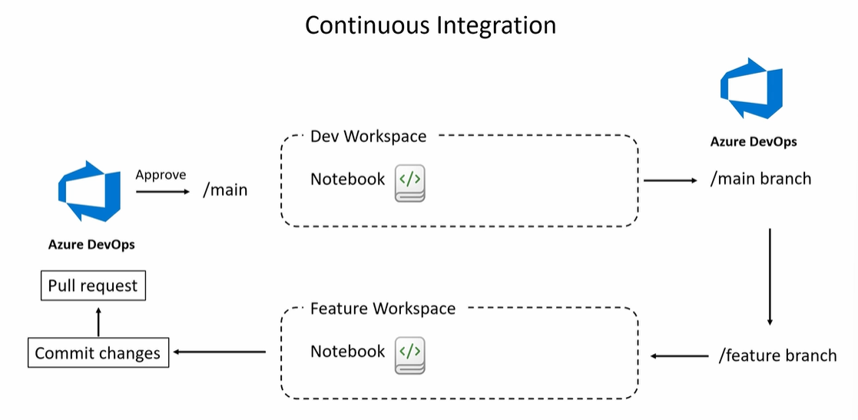
Some definitions
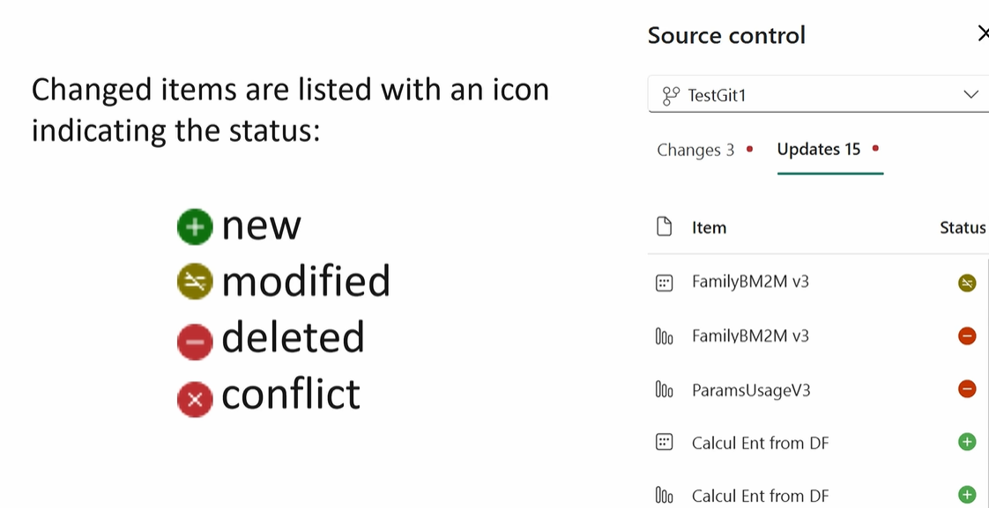
The Git integration is Not supporting Direct Lake mode for Power BI (right now but it will be possible in the future ), so we will need to setup our Semantic mode using import mode in stead

Permissions
https://www.udemy.com/course/master-microsoft-fabric-a-complete-end-to-end-project-cicd/learn/lecture/46197293#overview

Create a new branch on top of the main branch in Fabric
https://www.udemy.com/course/master-microsoft-fabric-a-complete-end-to-end-project-cicd/learn/lecture/46197311#overview
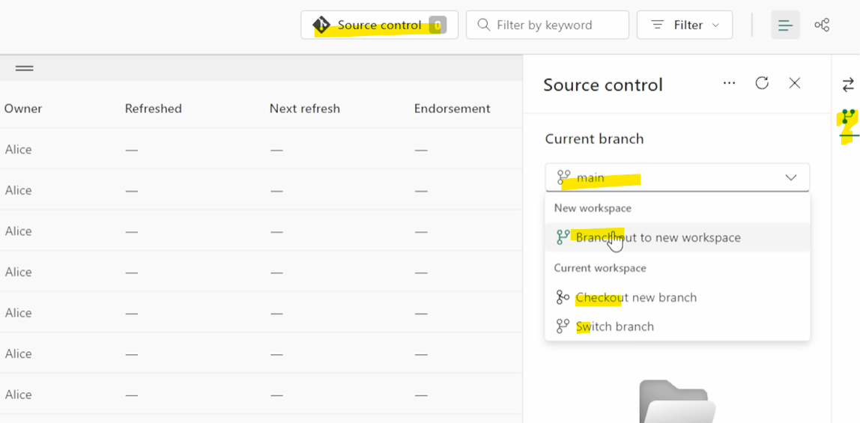
Note : The recommendation is use the Branch out to new workspace , witch will create a copy of the existing Fabric WS

Best Scenario in the branch strategy

Step1: Connect your fabric Dev_WS to Git (azure devops) so main branch (mb) = Dev_WS

Step2: Create a Feature branch (fe_Dev_WS) like recommended previously

Step3: Do all changes you need in this fe_Dev_WS) and commit those

Step4: Connect to Devops project and explore all the changes done in fe_Dev_WS

Step5: if all ok , do a PR from Devops project and approve, the changes will be merge to the mb

Step6: Commit (Or Update) your Dev_WS with the new changes merged into the mb

Fabric Deployment pipeline

Introduction
https://www.udemy.com/course/master-microsoft-fabric-a-complete-end-to-end-project-cicd/learn/lecture/46197317#overview

Create a deployment Pipeline
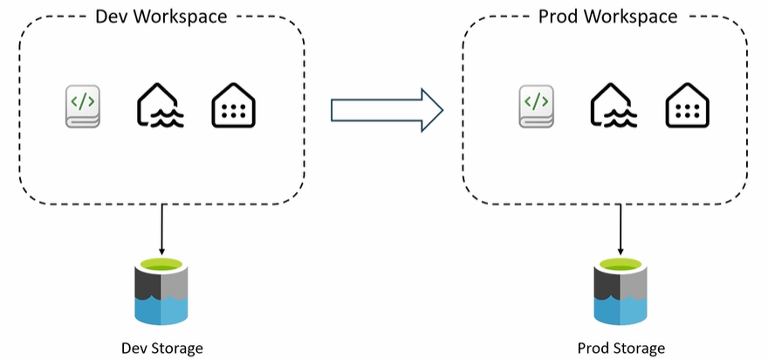
https://www.udemy.com/course/master-microsoft-fabric-a-complete-end-to-end-project-cicd/learn/lecture/46197321#overview
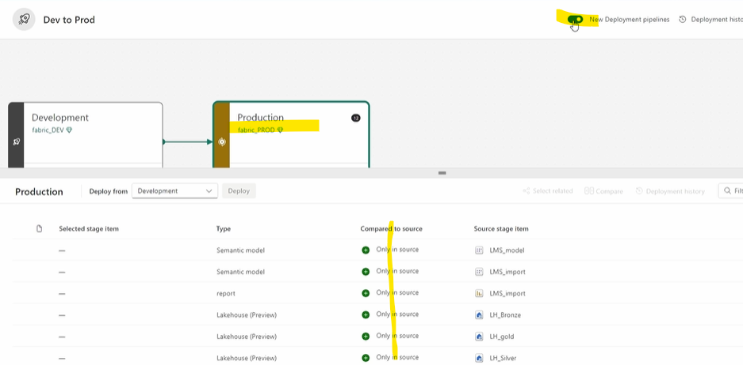
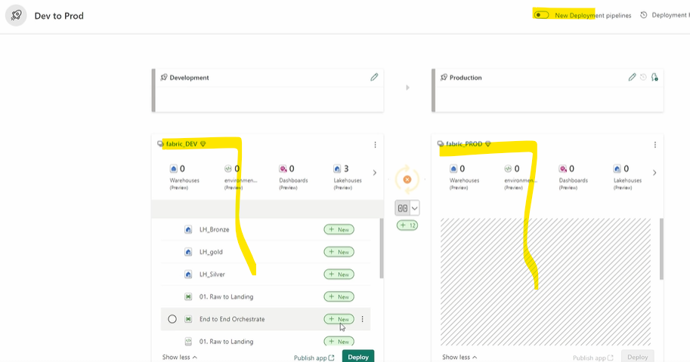

Deployment rules
https://www.udemy.com/course/master-microsoft-fabric-a-complete-end-to-end-project-cicd/learn/lecture/46197325#overview
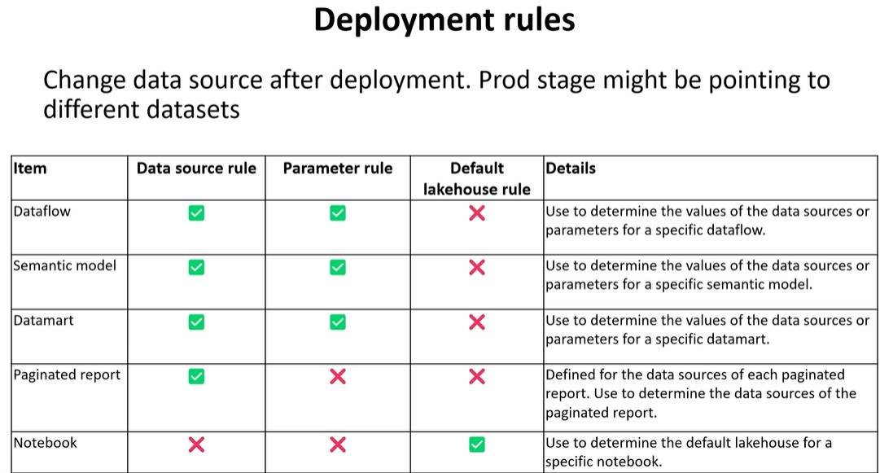

Git focus on Power BI
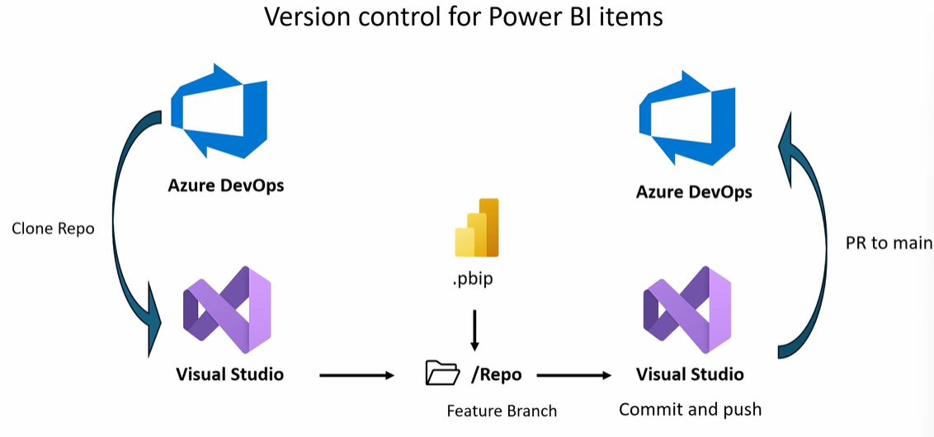
Power BI WS

https://www.udemy.com/course/master-microsoft-fabric-a-complete-end-to-end-project-cicd/learn/lecture/46197337#overview
By committing or updating from the PBI WS changes will be pushed from main intp the PBI WS
PR
Git will create a copy of the WS call main and others copy called feature
Power BI WS
Git
Connecting with Git
Feature branch
Main branch
Feature branch

Open PBIX file make changes and saved it as PBIP file

When change done a Pull Request can be created and Approved to merge all this changes to the main

Note: For the first time you will need to download the latest version to the PBI in .pbix file format and save it as a .pbip file in the feature branch which will be later merge to the main. And from now on, the file format will be maintained for future development when you will create a new feature branch

